Project Design Phase-II
Technology Stack (Architecture & Stack)

Date | 1 July 2026
Team ID
Project Name | Darshan Ease
Maximum Marks | 4 Marks

Technical Architecture:
The Deliverable shall include the architectural diagram as below and the information as per the table1 & table 2
Example: Order processing during pandemics for offline mode
Reference: https://developer.ibm.com/patterns/ai-powered-backend-system-for-order-processing-during-pandemics/
Guidelines:
Guidelines
- Include all the application processes (Application Logic / Technology Blocks):
  - User Registration & Login
  - JWT Authentication & Authorization
  - User Profile Management
  - Temple Management
  - Darshan Slot Management
  - Temple Search & Filtering
  - Slot Availability Checking
  - Online Darshan Booking
  - Payment Processing
  - E-Ticket Generation
  - Booking History Management
  - Notification Service
  - Reporting & Analytics
  - Admin Dashboard
  - Temple Staff Dashboard
- Provide infrastructural demarcation (Local / Cloud):
  - Local Infrastructure: User Devices (Desktop/Mobile), React Frontend, Node.js Server (Development)
  - Cloud Infrastructure: MongoDB Atlas Database, Backend Deployment (Render/Railway), Frontend Hosting (Vercel/Netlify), Cloudinary Storage, GitHub Repository
- Indicate external interfaces (Third-Party APIs / Services):
  - Razorpay Payment Gateway
  - Cloudinary (Image Storage)
  - Nodemailer / SMTP (Email Notifications)
  - Google Maps API (Temple Location)
  - SMS Gateway (Future Enhancement)
- Indicate Data Storage Components / Services:
  - MongoDB Atlas
  - Users Collection
  - Temples Collection
  - Darshan Slots Collection
  - Bookings Collection
  - Payments Collection
  - Reviews Collection
  - Notifications Collection
  - Contact Queries Collection
  - System Logs Collection
- Indicate interface to Machine Learning Models (if applicable):
  - Current Version: No Machine Learning integration.
  - Future Enhancements:
    - Crowd Prediction Model
    - Festival Demand Forecasting
    - Slot Recommendation System
    - Personalized Temple Recommendation
    - Queue Waiting Time Prediction
    - User Behavior Analytics

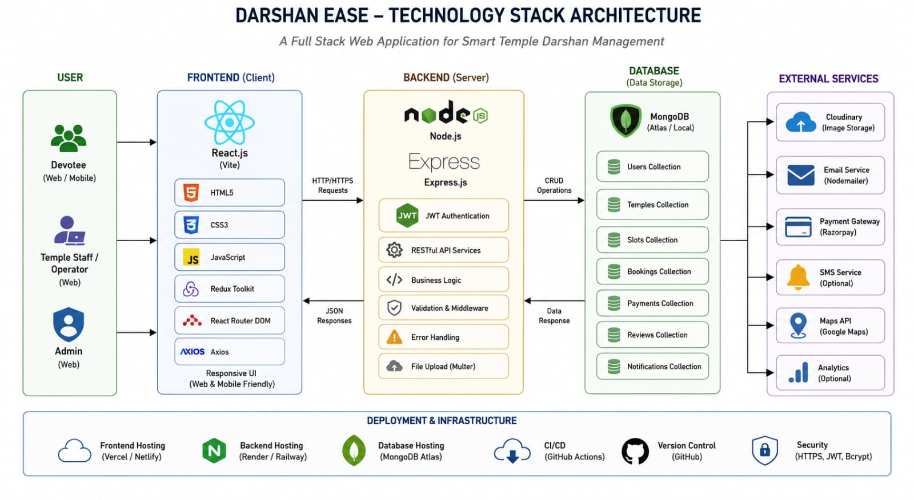

Table-1 : Components & Technologies:
S.No | Component | Description | Technology
 | User Interface | How user interacts with application e.g.  Web UI, Mobile App, Chatbot etc. | HTML, CSS, JavaScript / Angular Js / React Js etc.
 | Application Logic-1 | Logic for a process in the application | Java / Python
 | Application Logic-2 | Logic for a process in the application | IBM Watson STT service
 | Application Logic-3 | Logic for a process in the application | IBM Watson Assistant
 | Database | Data Type, Configurations etc. | MySQL, NoSQL, etc.
 | Cloud Database | Database Service on Cloud | IBM DB2, IBM Cloudant etc.
 | File Storage | File storage requirements | IBM Block Storage or Other Storage Service or Local Filesystem
 | External API-1 | Purpose of External API used in the application | IBM Weather API, etc.
 | External API-2 | Purpose of External API used in the application | Aadhar API, etc.
 | Machine Learning Model | Purpose of Machine Learning Model | Object Recognition Model, etc.
 | Infrastructure (Server / Cloud) | Application Deployment on Local System / Cloud  Local Server Configuration:  Cloud Server Configuration : | Local, Cloud Foundry, Kubernetes, etc.

Table-2: Application Characteristics:
S.No | Characteristics | Description | Technology
 | Open-Source Frameworks | List the open-source frameworks used | Technology of Opensource framework
 | Security Implementations | List all the security / access controls implemented, use of firewalls etc. | e.g. SHA-256, Encryptions, IAM Controls, OWASP etc.
 | Scalable Architecture | Justify the scalability of architecture (3 – tier, Micro-services) | Technology used
 | Availability | Justify the availability of application (e.g. use of load balancers, distributed servers etc.) | Technology used
 | Performance | Design consideration for the performance of the application (number of requests per sec, use of Cache, use of CDN’s) etc. | Technology used

References:
https://c4model.com/
https://developer.ibm.com/patterns/online-order-processing-system-during-pandemic/
https://www.ibm.com/cloud/architecture
https://aws.amazon.com/architecture
https://medium.com/the-internal-startup/how-to-draw-useful-technical-architecture-diagrams-2d20c9fda90d

